Administration

Customer

New Customer
Administration > Customer > New Customer
Fill up the form. Fields asterisk (*) mark are required. Others are optional.
Press Save or Save & Add Another button.

Description
System will save customer profile and create Ledger Account with account code prefix CS. Modify the opening balance of customer from Chart of Accounts

Search Customers
Administration > List Customer
By default this page lists all the customers. To list the specific customer enter Search String and press Search button; system will list only those customers whose first, middle or last name contain Search String.

Update Customer
Administration > List Customer
Press Update link against customer; under Action Column
Customer update page will appear with pre-fill customer profile; get from database.
Modify the profile; fields asterisk (*) mark are required. Others are optional.
Press Save button.

Description
System will save customer profile and update customer ledger account title in Chart of Accounts.
.

ITEMS

New Item

Search Items

Figure 1
List Group List 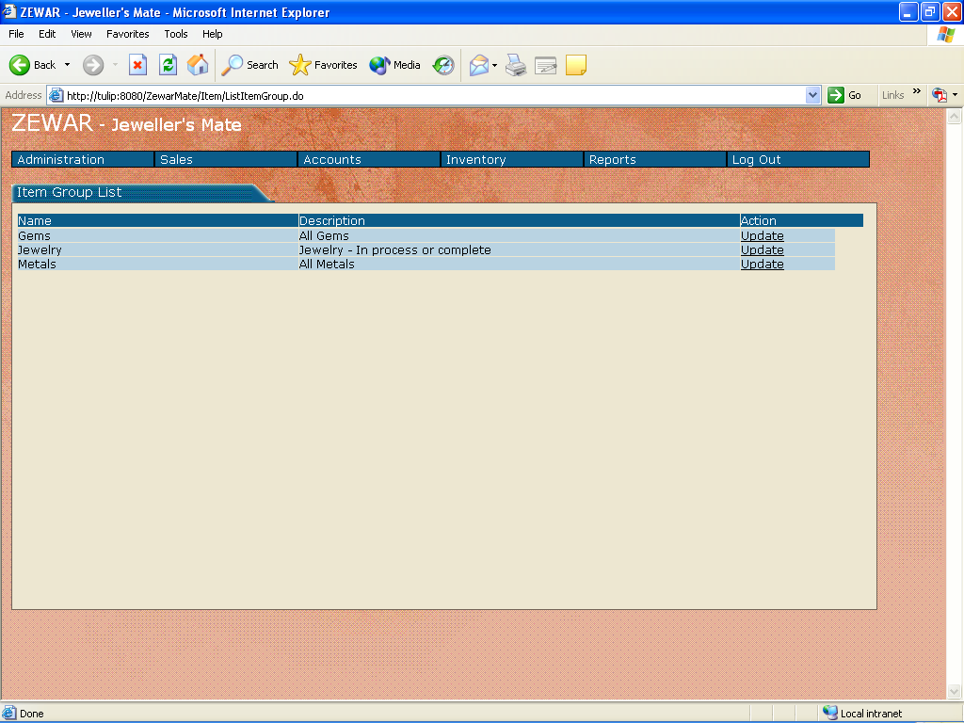
Figure 2

Users

New Users
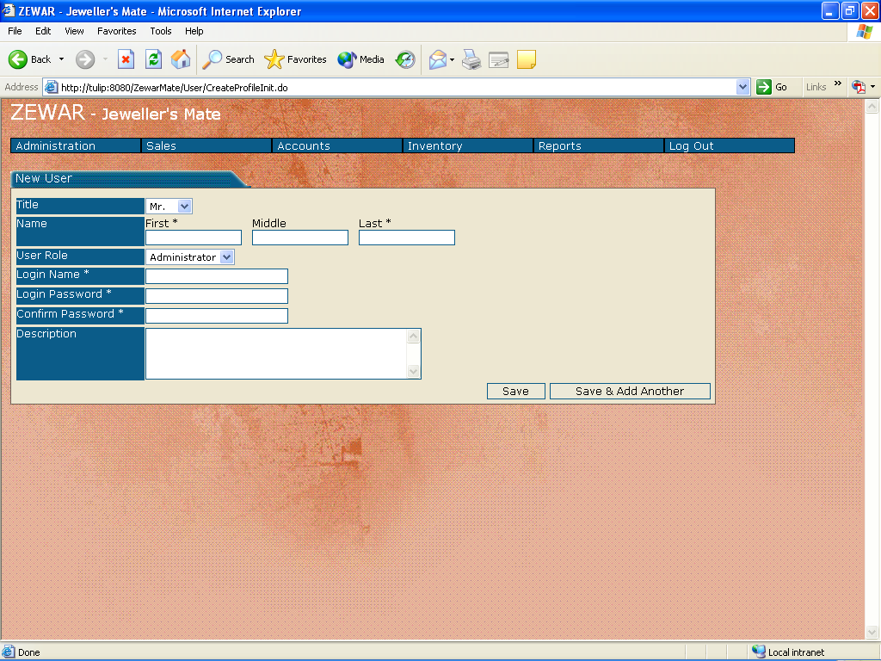
Figure 3
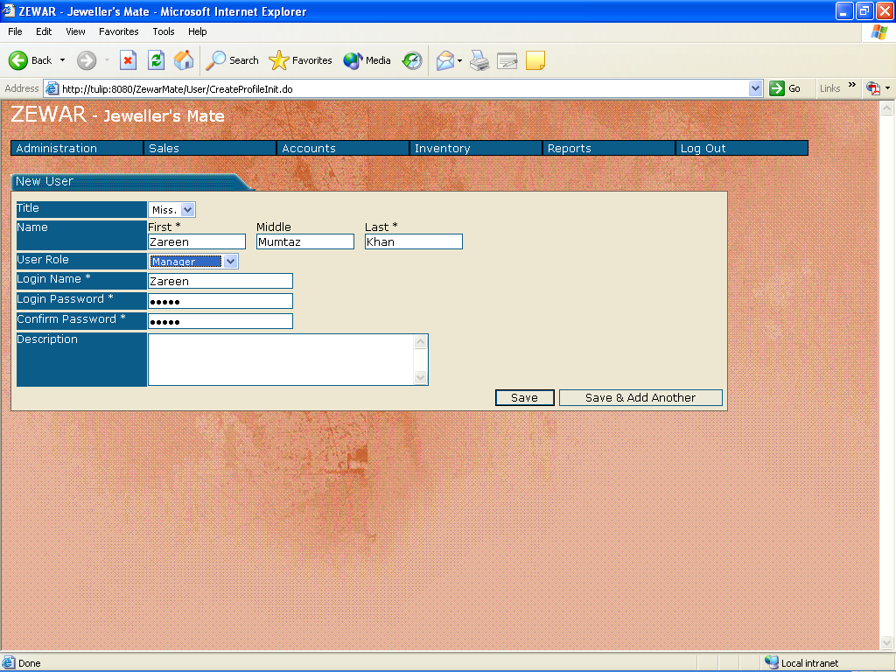
Figure 4

User List
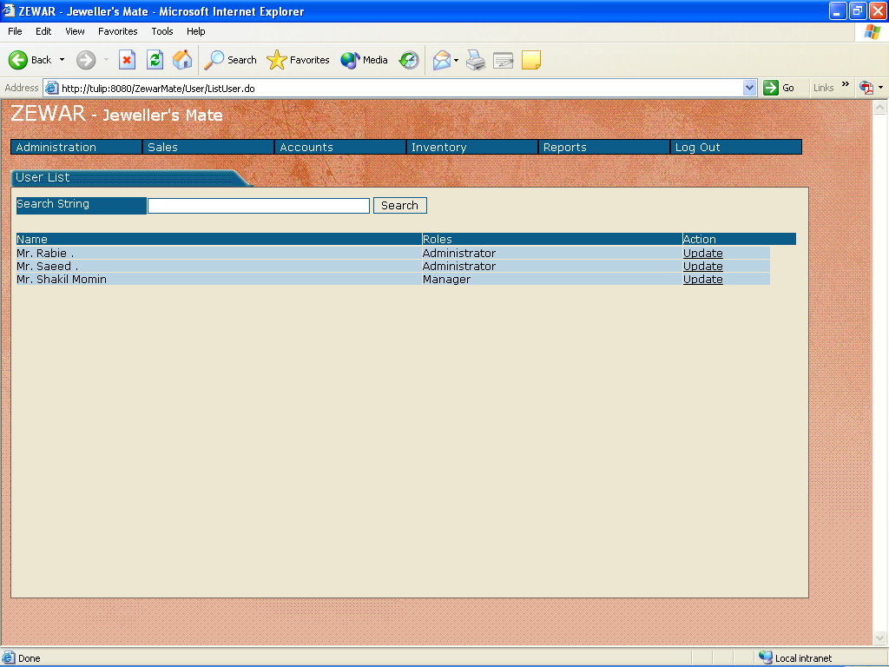
Figure 5

Vendors

New Vendors

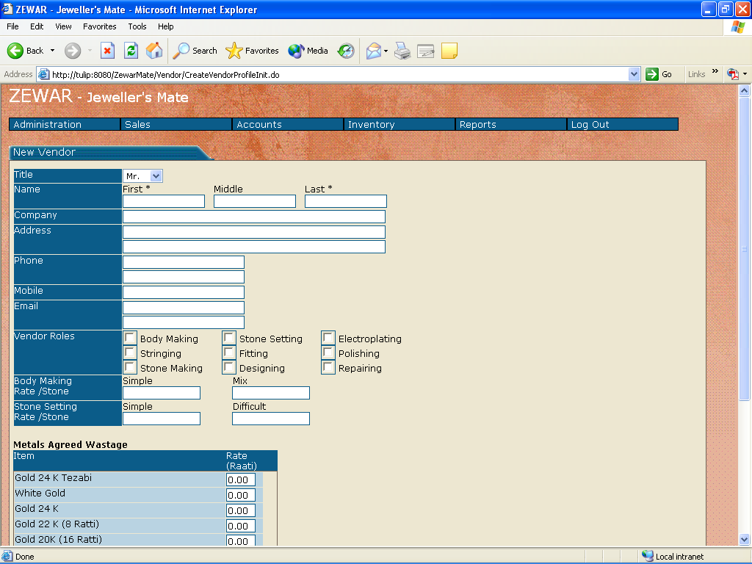
Figure 6
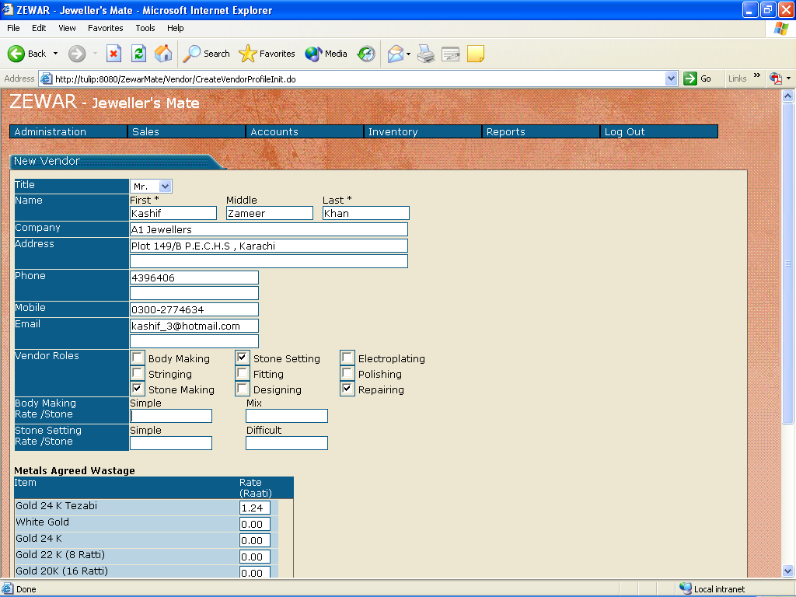
Figure 7

Vendor List
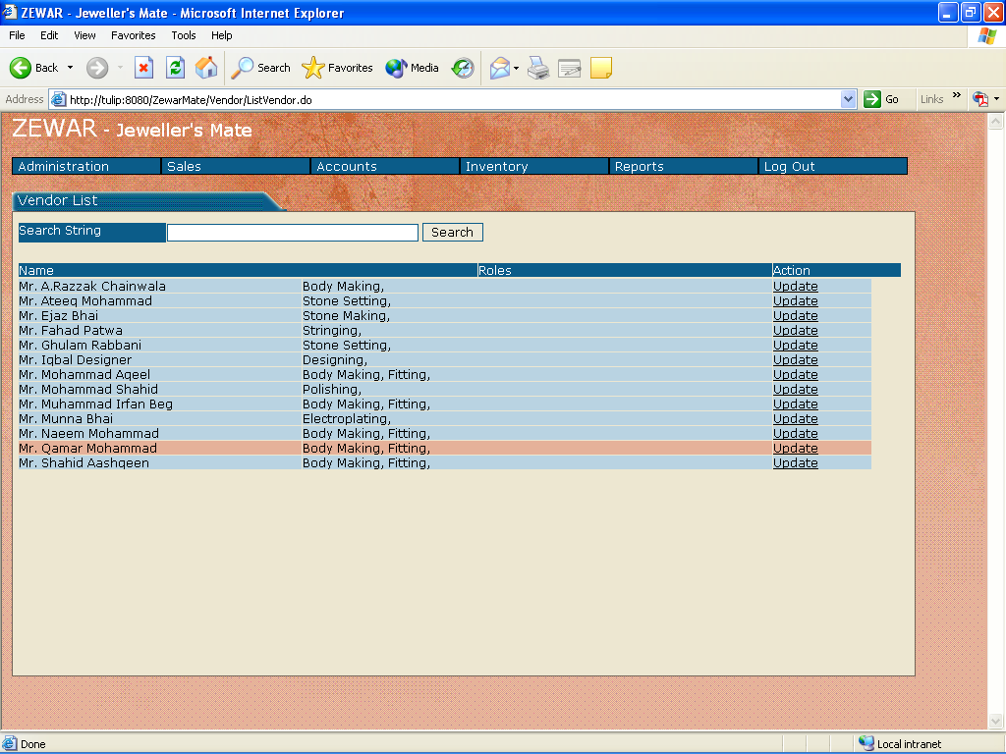
Figure 8

Vendor Group List
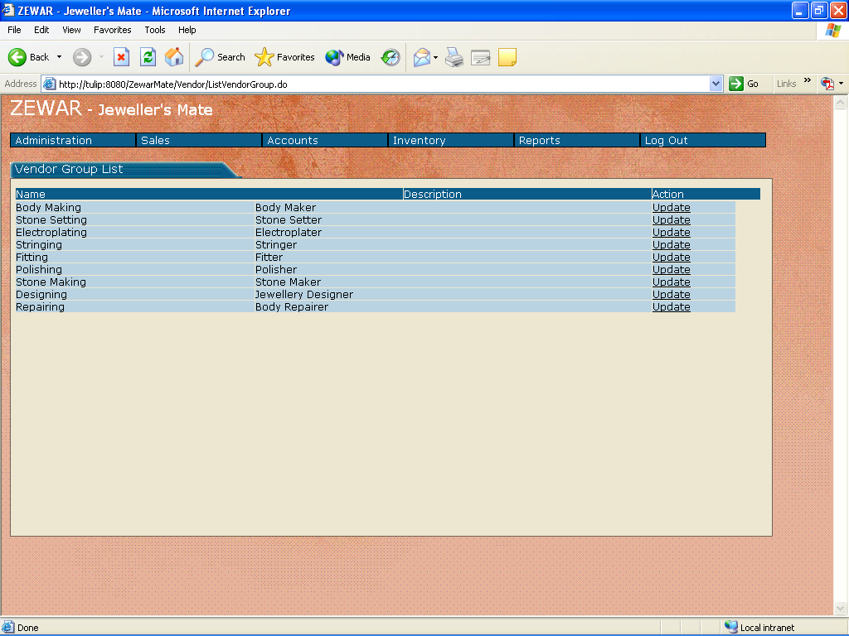
Figure 9

